# Department of Computing

# CS361: Computer Graphics

# Class: BSCS-5ABC

# Lab02: Mouse and Keyboard events

# Date: 10th September, 2018

# Time: 9:00- 12:00

# Instructor: Dr. Muhammad Muddassir Malik

# Lab02: Mouse and Keyboard events and Mirror Transformation

# Introduction

You can also detect a mouse click on your canvas. Again, this is done with addEventListener. There are quite a few mouse events you can detect: mousedown, mouseup, mousemove, mouseout and mouseover. As an example, here's some code that detects the mousedown event

**Objectives**

After performing this lab students should be able to:

Know the basics of HTML 5 Canvas, Under Stand Mouse and Keyboard events, Mirror Transformations

**Tools/Software Requirement**

For testing HTML 5, CSS, JS

<http://codepen.io/anon/pen/OyPdrV>

**Description**

**Mouse Events**

There are quite a few mouse events you can detect: mousedown, mouseup, mousemove, mouseout and mouseover. As an example, here's some code that detects the mousedown event

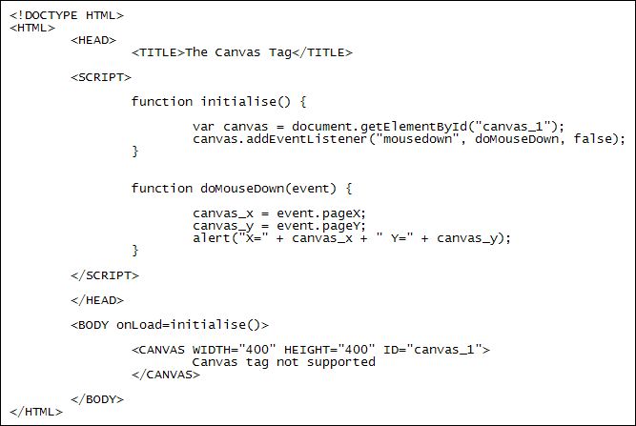

Reference: <http://www.homeandlearn.co.uk/JS/html5_canvas_mouse_events.html>

<https://developer.mozilla.org/en-US/docs/Web/API/Canvas_API/Tutorial/Transformations>

**Mirror Transformation**

<html>

<head>

<style>

body {

margin: 0px;

padding: 0px;

}

</style>

</head>

<body>

<canvas id="myCanvas" width="578" height="200"></canvas>

<script>

var canvas = document.getElementById('myCanvas');

var context = canvas.getContext('2d');

// translate context to center of canvas

context.translate(canvas.width / 2, canvas.height / 2);

// flip context horizontally

context.scale(-1, 1);

context.font = '30pt Calibri';

context.textAlign = 'center';

context.fillStyle = 'blue';

context.fillText('Hello World!', 0, 0);

</script>

</body>

</html

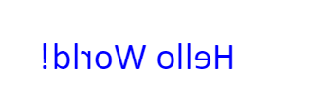

**Lab Task**

**​**  
**Task 1**

Create a webGL program to interact with the canvas. Draw a point where the user clicks on the screen. (7)

**Task 2**

Modify Task 1 so that on each click four points are drawn. One on top of the click location, one on its left, one to the right and one under it. (3)

**Deliverable**

Upload your full code with all the lib files.